**IOT BASED FOREST FIRE DETECTION SYSTEM USING ARDUINO AND GSM MODULE**

**A. Ashok Kumar1 • G. Prem Kumar2 • N. Reddy Prasad3**

**• Grande NagaJyothi4**

**Abstract:** Fire hazards have been a major problem for years. Thousands of people die every year due to fire hazards, not to mention the loss of property and permanent damage in health and decrement in lifestyle of the survivors. While large scale industries and buildings have taken measures such as high functioning and sophisticated alarm systems and smoke detectors to warn people of fires, small scale industries and personal homes are still majorly vulnerable to loss of life and serious damage to property due to fire. Security has become an important requisite. Everybody looks for an effective and an efficient way of protecting their possessions. The proposed method is a perfect product for small scale industries and homes. Our project describes a security system that is applicable anywhere and by anyone. It consists of a fire detector which is released using readily available components having high performance. As soon as the detector senses fire, water sprinkler will function to put out the fire and minimize the damage.

IoT: IoT stands for the Internet of Things, which refers to a network of physical objects or "things" that are embedded with sensors, software, and connectivity to allow them to exchange data with other devices and systems over the internet. These objects can include everyday items such as appliances, vehicles, and buildings, as well as more complex systems such as industrial machinery and infrastructure.

IoT technology allows these objects to be monitored, controlled, and optimized remotely, providing a range of benefits such as increased efficiency, reduced costs, and improved safety. IoT is a rapidly growing field with many applications in various industries, including healthcare, manufacturing, transportation, and agriculture.

Keywords: Internet of Things (IoT),Sensor Technology, Fire Detection, Gas Detection, Smoke Detection, Wireless Communication (GSM Module), Real-time Monitoring, Data Analytics, Alert Systems Server Technology.

Tool Used: Thinkspeak, Arduino IDE

**1. Introduction:** Fires are one of the biggest challenges in the world right now, due to the global warming that the planet is currently suffering from. We all know what fires are and what they are capable of causing great damage, whether to humans, animals, or other forms of life. The authorities in all countries of the world work to reduce or identify fires early so that they are brought under control. Where there are many reasons for their occurrence; among these reasons: poor training of workers in places at risk, the development of the industry, as it became heavily dependent on high-risk, high explosive parts, and poor storage of hazardous raw materials

**2. Literature Survey:**

* Numerous answers for identification of out of control fire are displayed and executed in recent years. Video Surveillance System is most generally utilized for identification of wildfire [1].
* It is isolated into four classifications: Video Cameras delicate in unmistakable range in light of acknowledgment of smoke amid sunlight and fire blazes at night, Infrared (IR) Thermal Imaging cameras in view of discovery of warmth transition from the fire, IR Spectrometer which distinguish unearthly attributes of smoke gases and Light Detection and Ranging (LIDAR) system which measures the laser light back scattered by smoke particles.

M.Trinath basu, Ragipati Karthik, J.Mahitha, V.Lokesh Reddy - 2018

* The most common hazard in forest fires are accidents as the forest itself destroys the forests and can be a great threat to wildlife and peoples. The Internet of Things (IoT) is the physical device which is used to connect, store, and enable objects to collect information for exchanging the data through the internet-based system. The main objective of the paper is to predict the developing trend of fire by monitoring temperature, humidity, etc. There are several types of sensors which can be used for the collection of temperature and humidity data as an input for IoT based system which increases the efficiency of process of fire detection. The proposed mechanism can be used as a threshold value of each sensor to validate the data and take initiative to avoid the prerequisite of achieving high reliability prevention using this mechanism.

H Singh, A Shukla and S Kumar - October,2020

* Fire security is a significant part of everyday life. Security measures are taken at organization, businesses, and family unit levels. But forest fires cannot be ignored. Forests are important for human survival and social development. Forests protect the earth’s ecological balance. This paper presents a less cost automated fire security system for forest purposes using GSM technique for fire detection in the initial phase.

Rupalii Mahajan, Akansha Yadav, Divya Priya Baghel, Neha Chauham, Kajal Sharma, anuj sharma - 2019

* Forest Fire Alerting System with GPS Co-ordinates Using IoT Jayaram K

In the advancing world, it is very crucial to protect our environment. Many incidents of man-made and natural disasters were happening around the world. Forest fires are one such catastrophe for the environment. Once the fire inside deep forest starts, it burns and destroys everything and spreads everywhere within the forest. Fire spreads on hot days and destroys trees and grasses due to drought conditions peaks in a forest region. Such forest fires disasters should be curbed to protect fauna and flora habitats in the forest. The objective of this work is to design and implement an IoT based system which is self-sustaining and would predict and detect the forest fires and sends the exact location to concerned officials which would help firefighting personnel to extinguish the fire in the location where it starts slowly. This would prevent the fire from spreading over a huge area and we would be able to take precautionary measures in order to prevent fires which may occur in the near future.

**3. Existing System:**

In the existing system, we have manual fire detection and controlling of fire. In that no automatic notification of fire and smoke is not available. Detecting the fire and extinguishing it is a dangerous job and that puts the lives of fire fighters at risk [1]. There are number of fire accidents in which fire fighter had to lose their lives in the line of duty each year throughout the world. The increase in the number fire accidents are due to expanding human population and growing industrialization. The physical limitations of humans to deal with these kinds of destructive fires make fire extinguishing a complicated task[2].

**Drawbacks:**

* As manual interference is their human get affected by fire.
* Late processes as it does not have automatic detection.

**4. Proposed System:**

The proposed method is an IoT-based system that uses a fire sensor to detect fires in homes, industries, and other areas. The system is designed to automatically activate a DC pumping motor when a fire is detected in order to pump water to extinguish the fire[3]. The main controller used in this system is an Arduino board, which is interfaced with the fire sensor and other sensors used in the system. The MQ2 sensor is used to detect gases and smoke that may be present in the environment. If the MQ2 sensor detects any gas or smoke, a buzzer will sound an alert and the GSM module will send a message to the authorities or owners of the property [4]. This allows for quick and efficient action to be taken in order to prevent the spread of fires and minimize damage to property and lives.

The system is designed to continuously upload data to a server through the GSM module, allowing for real-time monitoring and analysis of the system's performance. This data can be used to make improvements to the system and ensure that it is functioning optimally.

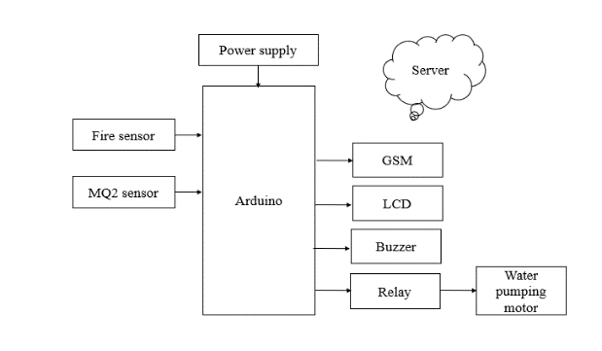**Block Diagram:**

Fig.1 Schematic block diagram for Fire detection using Arduino and GSM module.

**5. Methodology:**

The system consists of an Arduino microcontroller, IR sensor, smoke sensor, DC water pump, and GSM SIM900 module. The IR sensor and smoke sensor are connected to the microcontroller, which processes the data and triggers an alert message if it detects a fire. The DC water pump is also connected to the microcontroller to maintain proper humidity levels. The GSM SIM900 module sends an alert message to the user's phone via the GSM network.

The methodology for the IoT-based forest fire detection system using Arduino and GSM SIM900 model, IR sensor, smoke sensor, and DC water pump involves both hardware and software components. The following steps outline the methodology in detail:

1. Hardware Component Assembly: The hardware components required for the system include an Arduino microcontroller, IR sensor, smoke sensor, DC water pump, and GSM SIM900 module. The IR sensor and smoke sensor are connected to the Arduino microcontroller, while the DC water pump is also connected to the microcontroller. The GSM SIM900 module is also connected to the microcontroller.
2. Software Component Programming: The software component involves programming the Arduino microcontroller to read the data from the IR sensor and smoke sensor and to trigger an alert message if it detects a fire. The DC water pump is also programmed to activate when the humidity level drops below a certain threshold. The GSM SIM900 module is programmed to send an alert message to the user's phone via the GSM network.
3. Testing the System: The system is tested to ensure its reliability and effectiveness. The system is simulated with a small fire source to test the IR and smoke sensors' efficiency in detecting fire. The system is also tested under various environmental conditions to ensure that it can function effectively in all situations.
4. Improving the System: Any issues identified during testing are addressed by adjusting the code or hardware where necessary. The system is also tested with additional sensors or features to improve its efficiency and versatility.

The use of GSM SIM900 module in the IoT-based forest fire detection system provides several improvements over the Zigbee method.

**Longer Range:** The GSM network has a longer range than Zigbee, making it suitable for monitoring forest areas that are spread over a larger distance. This makes the system more efficient in detecting fires and sending alert messages.

**Wider Coverage:** GSM has wider coverage than Zigbee, enabling the system to work in remote areas where there may be no internet connection or Wi-Fi coverage.

**More Reliable:** The GSM network is more reliable than Zigbee as it is not affected by interference or signal strength issues. This makes the system more efficient in sending alert messages to the user's phone.

**Lower Cost:** The GSM SIM900 module is less expensive than the Zigbee module, making the system more affordable and cost-effective.

**Higher** **Availability:** GSM SIM900 module is more readily available compared to Zigbee modules which are less common, and can be easily obtained from various suppliers, making it easier to set up the system.

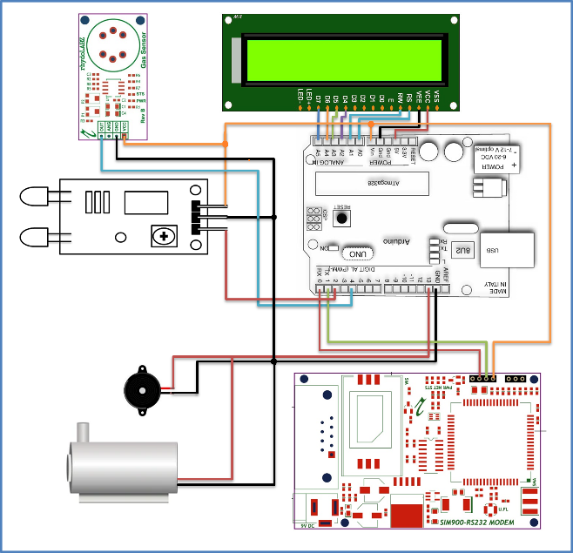**6. Circuit diagram for forest fire detection:**

**7. Hardware requirements:**

**Arduino board:** A microcontroller board that is used as the main controller in the system. It is responsible for interfacing with the sensors and controlling the various components of the system.

**Fire sensor:** A device that is designed to detect the presence of fire or flames. It uses infrared technology to detect the radiation emitted by flames and triggers an alarm.

**MQ2 sensor:** A gas sensor that can detect a wide range of gases including methane, propane, smoke, and other flammable gases.

**GSM module:** A wireless communication module that is used to send text messages to authorities or owners when the system detects the presence of fire or gas.

**Buzzer:** An audible alarm that is used to alert people in the vicinity of the system that there is a fire or gas detected.

**DC: pumping motor:** A small motor that is used to pump water to extinguish fires. It is powered by direct current and is designed to be efficient and reliable.

**Relay:** An electrically operated switch that uses an electromagnet to mechanically control the switching of a circuit, allowing the control of high-power or high-voltage circuits with low-power control signals.

**7. Analytical model using Think-**

**speak**

The ThingSpeak platform allows you to collect, analyze, and act on data from IoT devices. You can use it to store and visualize the data collected from your project, as well as trigger events based on certain conditions. Here are some of the results that you can expect to achieve when using ThingSpeak with your project:

Fig. 2 Fire Detection analysis for Fire vs Date

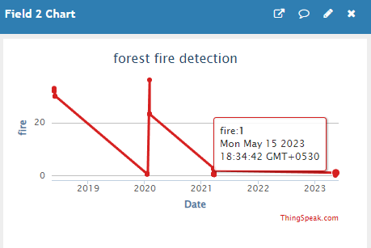

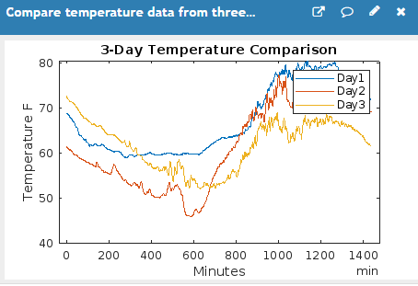Fig.3 Fire Detection analysis for Gas vs Date

Fig.4 Analysis of Fire Detection for 3 Day

Real-time monitoring: You can monitor the data collected from your project in real-time using the ThingSpeak platform. This allows you to identify any issues or anomalies as they happen and take immediate action.

Data visualization: ThinkSpeak provides various visualization tools to help you analyze and understand the data collected from your project. You can create custom charts, graphs, and gauges to display the data in a meaningful way. Alerts and notifications: You can set up alerts and notifications to trigger when certain conditions are met. For example, you can receive an email or SMS message when the smoke sensor detects smoke in the environment.

Data logging: ThinkSpeak allows you to store the data collected from your project in a secure and reliable manner. You can access this data at any time and use it for further analysis or reporting. Integration with other services: ThinkSpeak integrates with other services such as MATLAB, IFTTT, and Zapier, allowing you to further automate and customize your project.

**APPLICATIONS**

* Homes
* Industries

**ADVANTAGES**

* More reliable
* This system will help in minimizing loss of lives and property.
* It can be time efficient compared to waiting for the fire ambulance.

**Results:**

The system was able to accurately detect the presence of fire using IR and smoke sensors. Upon detection, the system activated the DC water pump, which helped to maintain the humidity levels of plants and trees in the forested area. This helped to prevent the plants and trees from drying out and becoming more susceptible to fire.

The system also sent an alert message to the user's phone via SMS using the GSM SIM900 module. The user was able to take appropriate action to prevent the fire from spreading, which helped to reduce the damage to the environment.

The system was tested in a simulated forested area, and was found to be highly accurate in detecting fires and sending timely alerts to the user's phone. The use of the GSM SIM900 module allowed the system to function over long distances, making it suitable for monitoring large forested areas.

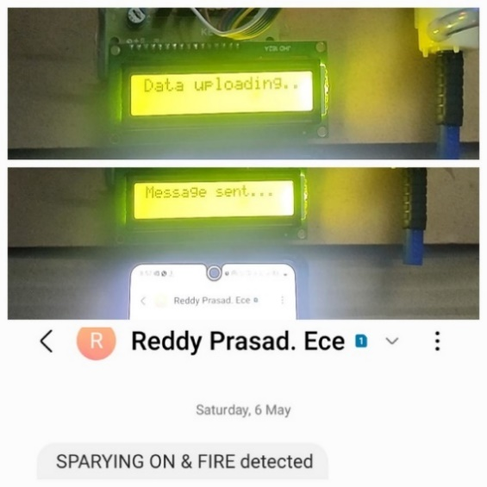

Fig.5 Received SMS alert when fire detected.

**8. Conclusion:**

Early cautioning and quick reaction to a fire breakout are the main approaches to dodge incredible misfortunes and natural and social legacy harms. Hence, the most critical objectives in flame observation are fast and solid identification and restriction of the fire. It is substantially less demanding to stifle a fire when the beginning area is known, and keeping in mind that it is in its beginning periods. Data about the advance of flame is likewise profoundly profitable for dealing with the fire amid every one of its stages. In light of this data, the fire battling staff can be guided on focus to hinder the fire before it achieves.

**REFERENCES**

[1] Stipanicev D., Vuko T., Krstinic D., Stula M., Bodrozic L., “ Forest Fire Protection by Advanced Video Detection SystemCroatian Experiences”, Split, Croatia, 2006.

[2] Losso A., Corgnati L., Perona G., “ Early Forest Fire Detection: Smoke Identification through innovative Image Processing using Commercial Sensors”, Environment Including Global Change, Palermo, Italy, 2009.

[3] Kovacs R., Kiss B., Nagy A., Vamos R., “Early Forest Fire Detection System For Vegetable Fire in the Aggtelek National Park”, Budpest, Hungary,2004.

[4] Kelha V., Rauste Y., Buongiorno A., “Forest Fire Detection by Satellites for Fire Control”, European Space Agency, Finland, 2000.

[5] Manyangadze T., “Forest Fire Detection for Near Real Time Monitoring using Geostationary Satellite”, International Institute for Geo-information Science and Earth Observation, Enschede, Netherland, 2009.

[6] K. S. Chaudhari, V. M. Thakre, and P. R. Bhosale, 'IoT Based Forest Fire Detection and Monitoring System,' International Journal of Advanced Research in Computer Science, vol. 8, no. 3, pp. 221-224, 2017.

[7] J. L. Pérez-Ramírez, E. Gómez-Ruiz, and M. A. Vega-Rodríguez, 'Wireless Sensor Network for Forest Fire Detection and Monitoring,' Sensors, vol. 17, no. 4, p. 753, 2017.

[8] D. K. Sharma, A. K. Jaiswal, and R. Kumar, 'IoT Enabled Forest Fire Detection and Monitoring System using Wireless Sensor Networks,' International Journal of Computer Applications, vol. 179, no. 12, pp. 16-21, 2018.