Blockchain Based Covid Vaccine Booking

**Mr. G. Narahari Reddy1, Dr. K. Sekhar2, Dr. R. Suresh3**

*1 Dept. of CSE, SVCE, Tirupati, Email:* [narahari.1994@gmail.com](mailto:narahari.1994@gmail.com)

*2 Professor, Dept. of CSE, SVCE, Tirupati, Email:* [sekhar.k@svcolleges.edu.in](mailto:sekhar.k@svcolleges.edu.in)

*3 Associate Professor, Dept. of CSE, SVCE, Tirupati, Email:* [Suresh.rm@svce.edu.in](mailto:Suresh.rm@svce.edu.in)

**Abstract –** Immunization is all about using Block chain for managing and tracing the vaccine stocks, logistics and transparent distribution. Immunization gives you continuous visibility and enables actionable insights to track vaccine distribution and ensure a fair and equitable distribution. Immunization allows you to book your vaccination appointments and will also allow you to keep track of the vaccine being distributed. Block chain helps in maintaining the integrity and transparency of the whole process right from inception of the vaccine.

**Index Terms –** Vaccine report using Blockchain; COVID-19; Immunization programs; Transparent Vaccine status.

1. **INTRODUCTION**

The prevalence of corona virus which leads to respiratory infections with symptoms ranging from the common cold to more severe diseases such as Middle East Respiratory Syndrome (MERS) and Severe Acute Respiratory Syndrome (SARS). Since then, the eyes of the world have been on the pharmaceutical sector as industry leaders race to test, produce and distribute a vaccine to combat COVID-19.

On March 11, WHO concluded that COVID-19 could be a pandemic. Worldwide the partners are working together to reduce the spread of disease by developing multiple vaccines. Once a vaccine is approved by WHO for common people’s disposal, attention will turn on to the orchestration and the planning done by the respective Governments for the vaccine status and the methods to be used by them such as patient health information and distribution, especially if special storage condition is required.

Name Of Vaccines Approved and Used in India are:

1. Covaxin

2. Covishield

3. Sputnik

1. **RELATED WORK**

For optimal distribution of vaccines, ICT solutions used to support immunization campaigns. A drive through vaccination stimulation tool was utilized to manage time efficiency, requirements of staff and intervals for immunization which was based on event processing and agent-based modelling. During the outbreak of influenza, distribution of vaccine for a heterogenous population has been done using mathematical modelling to ensure fairness and managing the number of doses.

1. **BLOCKCHAIN SYSTEM FOR VACCINE BOOKING**

Blockchain basically works for holding a set of information like a ledger. All the actions taking place in the blockchain is known as the transactions that serves the purpose requested by the user. The user or the peer in the network form the node. And all the nodes combined together forms a peer-to-peer decentralized chain/network. Once a node requests for service the miners mine solving the puzzle creating a block and in return they get rewarded based on the complexity of the puzzle. The network follows consensus protocol like proof of stake algorithm or proof of work algorithm. Each and every block created is visible to all the nodes in the network and each node is supposed to validate the block being created and once validated the block is added to the existing network and the transaction requested is completed and the same procedure is followed for each and every request made by one or the other node.

**Methodology and Algorithms**

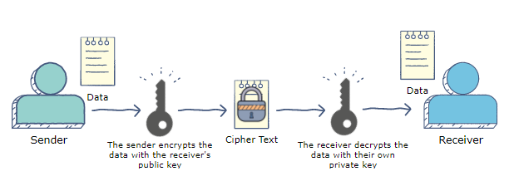

**Data Encryption**

Data encryption translates data into another form, or code, so that only people with access to a secret key (formally called a decryption key) or password can read it. Encrypted data is commonly referred to as ciphertext, while unencrypted data is called plaintext. Currently, encryption is one of the most popular and effective data security methods used by organizations. Two main types of data encryption exist - asymmetric encryption, also known as public-key encryption, and symmetric encryption.

**Purpose:**

The purpose of data encryption is to protect digital data confidentiality as it is stored on computer systems and transmitted using the internet or other computer networks. The outdated data encryption standard (DES) has been replaced by modern encryption algorithms that play a critical role in the security of IT systems and communications.

These algorithms provide confidentiality and drive key security initiatives including authentication, integrity, and non-repudiation. Authentication allows for the verification of a message’s origin, and integrity provides proof that a message’s contents have not changed since it was sent. Additionally, non-repudiation ensures that a message sender cannot deny sending the message.

**Data Decryption**

Decryption is the process of transforming data that has been rendered unreadable through encryption back to its unencrypted form. In decryption, the system extracts and converts the garbled data and transforms it to texts and images that are easily understandable not only by the reader but also by the system. Decryption may be accomplished manually or automatically. It may also be performed with a set of keys or passwords. One of the foremost reasons for implementing an encryption-decryption system is privacy. As information travels over the World Wide Web, it becomes subject to scrutiny and access from unauthorized individuals or organizations. As a result, data is encrypted to reduce data loss and theft. Some of the common items that are encrypted include email messages, text files, images, user data and directories. The person in charge of decryption receives a prompt or window in which a password may be entered to access encrypted information.

**Implementation:**

This module includes home page, user registration, user login, doctor login pages

The user registers himself and takes the preliminary tests and can check the details of the disease and can book the appointment for taking vaccines and in the token confirm page can check whether his booking has been confirmed or not by the hospital management.

A Doctor logs into his account and can check about his information in the home page, the home page also shows the number of visitors he has had and the appointment verify page shows the appointments booked by patients and the doctor can either confirm. Patient can register, can login, fill the information related to the medications taken for other sickness and the doctor can decide when the person needs to take the vaccine. Meanwhile the patient can book appointment for the preferred hospital. Patient can see the appointment status in their login.

1. **EXPERIMENTAL SETUP**

The idea was conceived to be used as an web-based application to create a more trustworthy and hassle free platform for vaccination appointment booking. This module includes home page, user registration, user login, doctor login and about blockchain transaction. The user registers himself and takes the preliminary tests and can check the details of the disease and videos uploaded by the Hospital staffs and can book the appointment for taking vaccines and in the token confirm page can check whether his booking has been confirmed or not by the hospital management.

**Software development life Cycle (SDLC):**

In our project we use waterfall model as our software development cycle because of its step-by-step procedure while implementing.

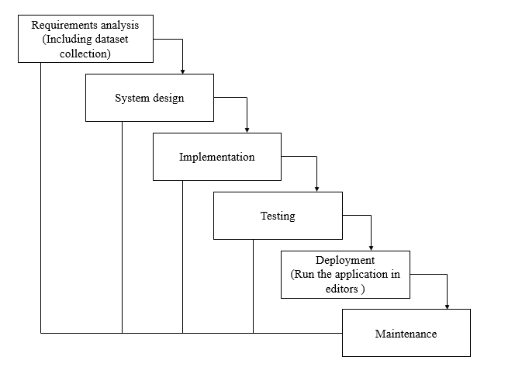

**Fig: Waterfall Model**

* **Requirement Gathering and analysis** − All possible requirements of the system to be developed are captured in this phase and documented in a requirement specification document.
* **System Design** − The requirement specifications from first phase are studied in this phase and the system design is prepared. This system design helps in specifying hardware and system requirements and helps in defining the overall system architecture.
* **Implementation** − With inputs from the system design, the system is first developed in small programs called units, which are integrated in the next phase. Each unit is developed and tested for its functionality, which is referred to as Unit Testing.
* **Integration and Testing** − All the units developed in the implementation phase are integrated into a system after testing of each unit. Post integration the entire system is tested for any faults and failures.
* **Deployment of system** − Once the functional and non-functional testing is done; the product is deployed in the customer environment or released into the market.
* **Maintenance** − There are some issues which come up in the client environment. To fix those issues, patches are released. Also, to enhance the product some better versions are released. Maintenance is done to deliver these changes in the customer environment.

1. **RESULT**

Implementation is the step in the project development where the theoretical flow is turned into a fully functional working system for the user that it will work effectively than the existing system. It involves careful observation, examination of the current system and its curb on current implementation, outline methods to achieve the change, and a regular inspection of change over methods to make sure the project is working well as expected.

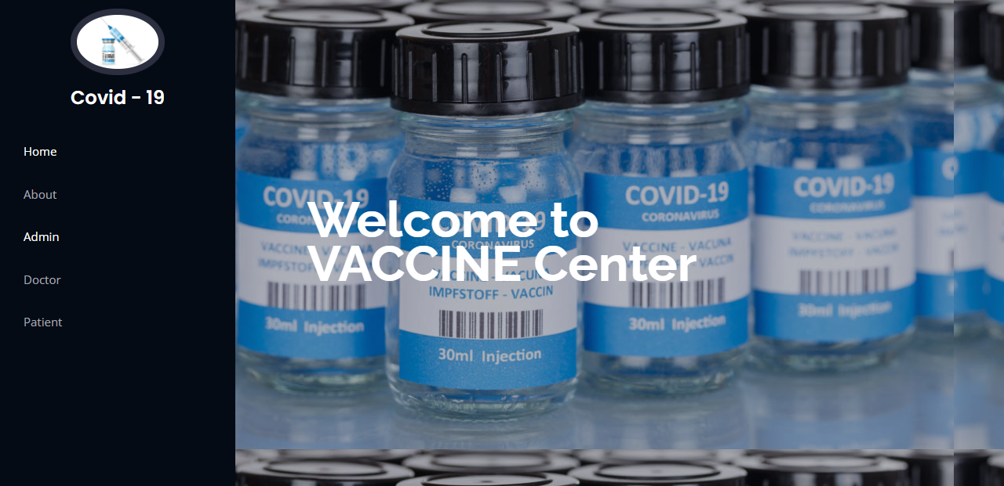

Thus, Immunization is all about managing and tracing the vaccine stocks, logistics and transparent distribution. Immunization gives you continuous visibility and enables actionable insights to track vaccine distribution and ensure a fair and equitable. Immunization allows you to book your vaccination appointments and will also allow you to keep track of the vaccine being distributed.

1. **CONCLUSION**

In the research, the blockchain based system was implemented to trace the registration, Result status and delivery of Covid-19 vaccine. Based on the findings, a blockchain solution is proposed for transparent vaccine distribution which manages the following:

1. Tracing the storage and delivery of Covid-19 vaccine with increased efficiency and transparency.
2. Assuring valid registration and monitoring the waiting test for immunization.
3. Providing a clear public reporting system.
4. Monitoring the storage temperature for

different Covid-19 vaccine.

1. Building a transparent system where each user will be updated of the vaccine transactions along with the network administrator.
2. **REFERENCES**
3. Sheng-I Chen, Bryan A. Norman, Jayant Rajgopal, Tina M. Assi, Bruce Y. Lee & Shawn T. Bro wn (2014) A planning model for the WHO -EPI vaccine distribution network in developing countries, IIE Transactions, 46:8, 853-865
4. Shakiba Enayati, Osman Y. Özalt ın, Opt imal influenza vaccine distribution with equity, European Journal of Operat ional Research, Vo lu me 283, Issue 2, 2020, Pages 714-725
5. Yu wen Yang, Hoda Bidkhori, Jayant Rajgopal, Optimizing vaccine distribution networks in low and middleinco me countries, Omega, Volu me 99, 2021, 102197, ISSN 0305-0483
6. A. Riewpaiboon, C. Sooksriwong, N. Chaiyakunapruk, P. Tharmaphornpilas, S. Techathawat, K. Rookkapan, A. Rasdjarmrearnsook, C. Su raratdecha, Optimizing national immunization program supply chain management in Thailand: an economic analysis, Public Health, Vo lu me 129, Issue 7, 2015, Pages 899-906.
7. Matt J. Keeling, Andrew Shattock, Optimal but unequitable prophylactic distribution of vaccine, Epidemics,Volu me 4, Issue 2, 2012, Pages 78-85
8. Ignaciuk, P.; Wieczorek, Ł. Continuous Genetic Algorith ms in the Optimizat ion of Logistic Networks: Applicability Assessment and Tuning. Appl. Sci. 2020, 10, 7851.Authors